Google Earth Activity

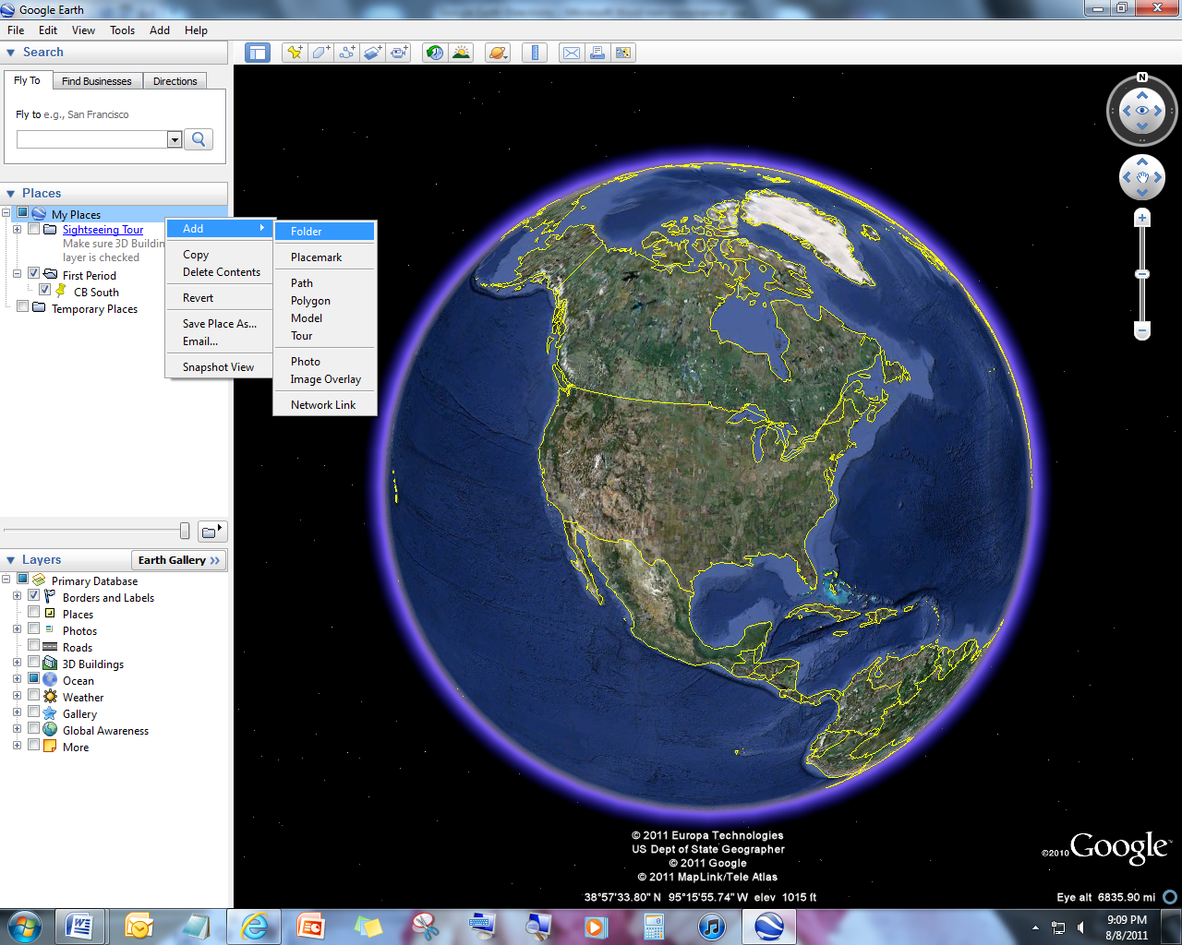**Part 1: Practice**

**Step 1**: Open Google Earth and create a folder in which you can store all of your place marks. Right click on My Places🡪Add🡪Folder.

**Step 2**: Enter your desired location in the search bar. For example, type Antarctica.

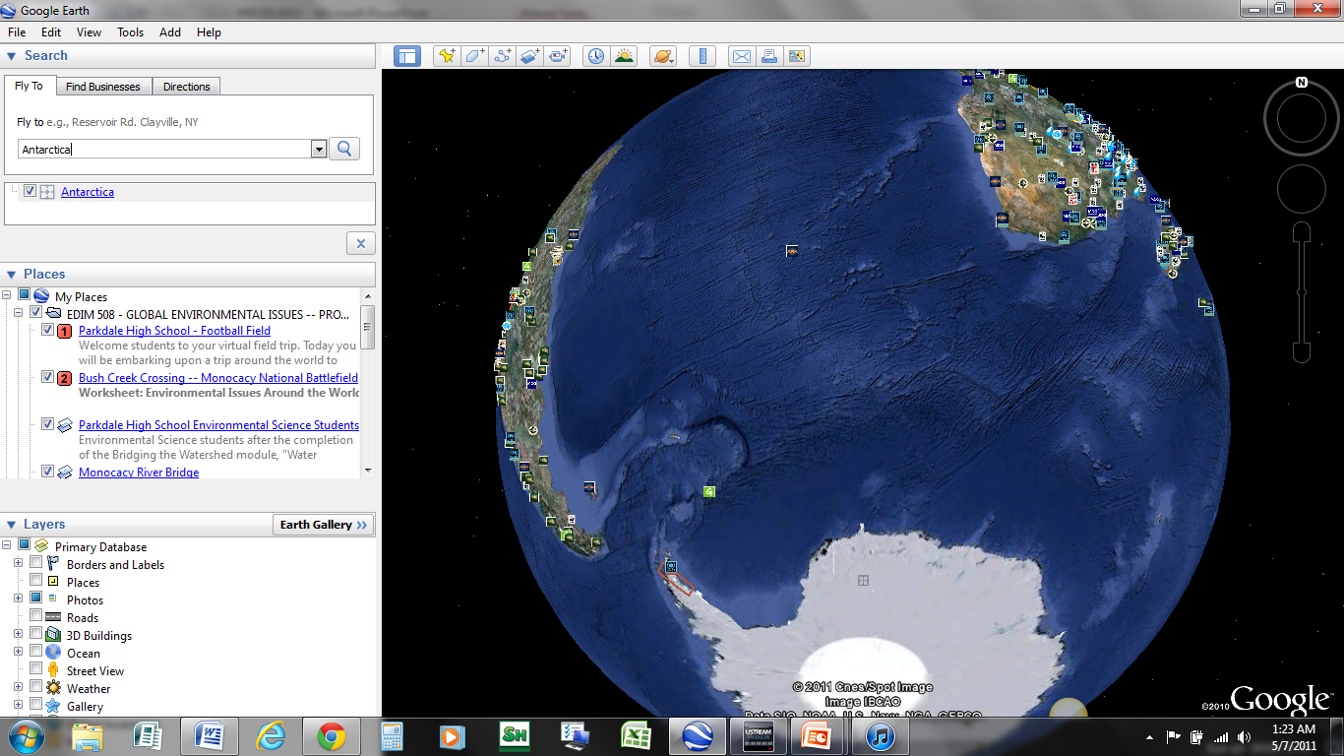

**Step 3:** Create a place mark. Right click on the desired folder and then click Add 🡪 Placemark. A dialog box will appear asking you to name the placemark you just created. Click on the icon to customize your placemark.

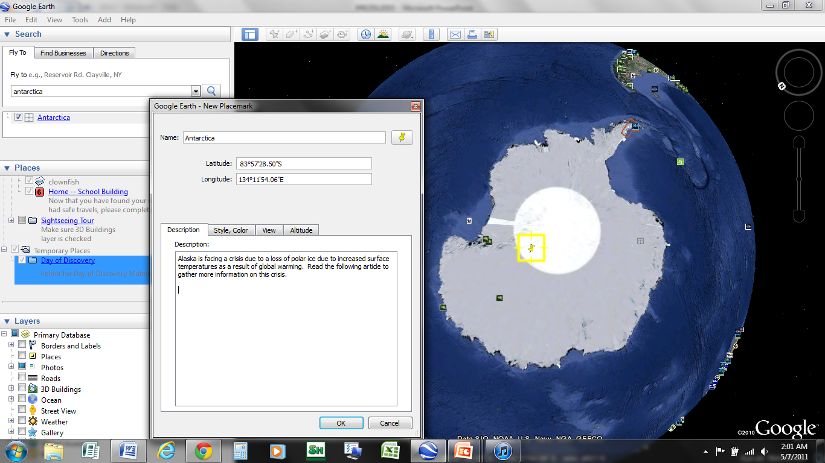

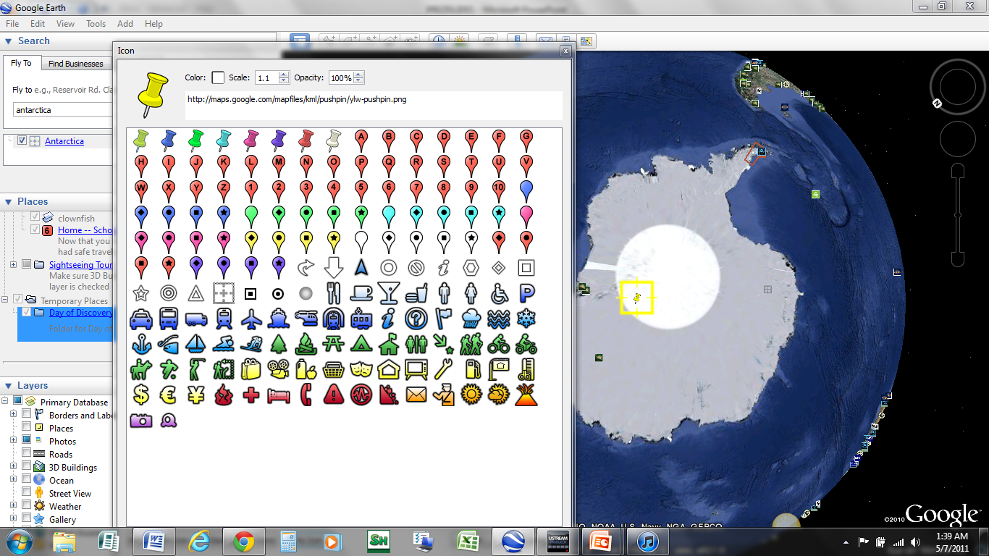

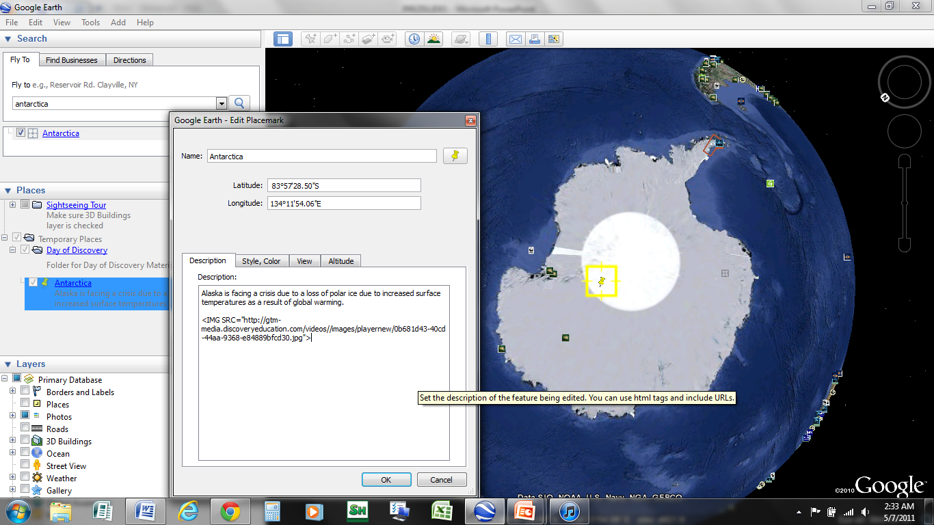**Step 5:** In the description box, you can add: Text, pictures, videos, widgets, anything that can be embedded.

1. 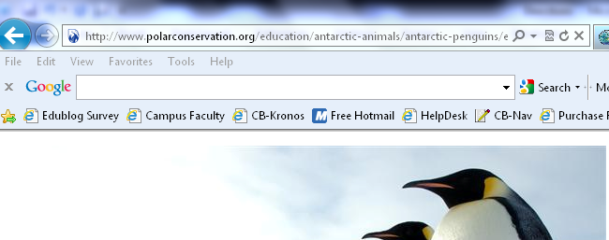**Text**-type or copy and paste into the box.
2. 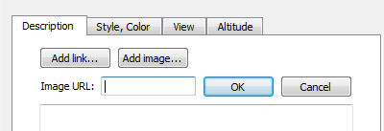**Images**-copy the URL from any image on the web. It must end in an image extension (i.e. .jpg, .gif..etc). Then click on the **Add image**..button. Paste the url into the box and hit ok.
3. **Videos-** paste any embeddable code into the description box. Youtube is a good place to start.

**Step 6:**  Continue to add more placemarks. Make sure you always Right click on the **same folder** so all your locations stick together. Right click on the folder and hit Add 🡪 Placemark. A dialog box will appear asking you to name the placemark you just created. Click on the icon to customize your placemark.

**Step 7:** Save your tour as a KMZ file by right clicking on the folder🡪Save Place As🡪Name and save your file. You will find a small KMZ icon to reopen your file or to email to a student.

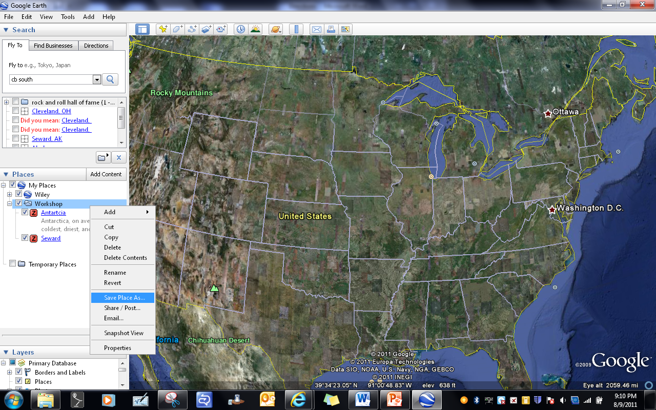



**Part 2: Things to Try**

1

2

3

4

1. **View an image of your home, school or any place on Earth**- Click **Fly To**. Enter the location in the input box and click the Search button. In the search results (Places panel), double click the location. Google Earth flies you to this location.
2. **View recent historical imagery for your favorite locations** - Choose the Clock**1** button to enable **Historical Imagery**. Then, use the time slider to view interesting placemarks throughout recent history.
3. **View 3D terrain of a place** - This is more fun with hilly or mountainous terrain, such as the Grand Canyon. Go to a location (see number 1). When the view shows the location, use the zoom slider to tilt the terrain. Hold the SHIFT key and scroll the mouse or hold the ALT key and scroll the mouse.
4. **Show Daylight across the US**- Use the timeslider**2** to show where light and dark occurs over the globe.
5. **Viewing a location in Google Maps**- Find and location and click on the Google Maps icon**4**.
6. **Measure Distance**-Try to measure the distance between two points when using the Ruler Tool**3**.
7. **Explore** [**http://tinyurl.com/googleearthcb**](http://tinyurl.com/googleearthcb)- Explorer the links to Google Lit trips or watch the videos for Google Earth Tutorials.